NOTEBOOK 5 REPORT
Data Pre-processing IV: Reduction, Splitting and Model Readiness
Student: ARINDA ELIZABETH
Registration Number: 2024/A/KCS/3099/G/F
Project: Predicting Monthly Maize and Beans Prices in Selected Ugandan Markets
This report is based on the project dataset, the notebook work, and the figures produced during the assignment. It explains what was done in Notebook 5 in simple language.

1. What this notebook was about
Notebook 5 belongs to Stage 9 of the assignment. This stage was about preparing the dataset for the final model. The work included cleaning the selected feature set, checking correlation, testing PCA, and splitting the data into training and testing parts.
The main target variables were c_maize and c_beans. These are the completed monthly price values for maize and beans. The task was to prepare a dataset that could be used for prediction while avoiding data leakage.

2. Data preparation
The notebook first loaded the selected market dataset. It then encoded the market name column using one-hot encoding. This was important because the market name is a category and machine learning models do not work well with text labels in their raw form.
The notebook selected a set of useful variables such as year, month, latitude, longitude, oil prices, salt prices, food price index, inflation values, trust values, and data quality indicators. It also kept the market dummy variables created from the market names.
Rows with missing values in the selected feature and target columns were removed. This made the final dataset cleaner and easier to model.

3. Feature selection and correlation
The notebook checked how each feature related to the target variables. It created a correlation table and also produced a heatmap. This helped the team see which variables had a strong relationship with maize and beans prices.
The strongest links were seen between the price targets and variables such as the food price index, oil price, and year. Month had a weak relationship with the target variables, which showed that month alone was not a strong predictor in this dataset.
The final decision was to keep the selected features. The number of variables was still small, and each feature had a clear meaning. Removing too many variables would have weakened the analysis and reduced useful information.
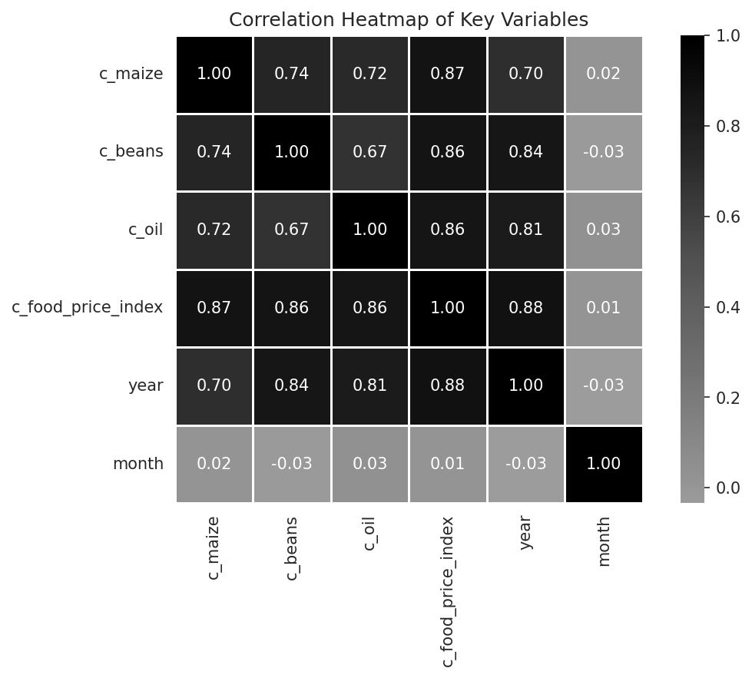
Figure: Figure 3_heatmap
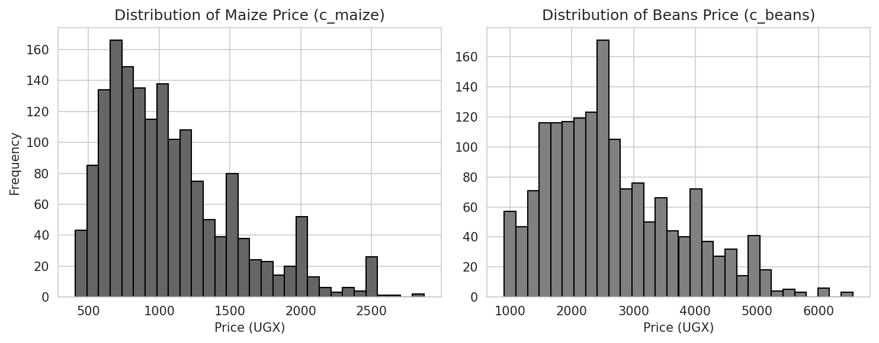
Figure: Figure 1_histograms

4. PCA review
PCA was used as an exploratory step. PCA is a way of reducing many variables into fewer components that capture the most variation in the data. The scikit-learn web guide explains that PCA projects data onto principal axes and keeps the dimensions that explain most variance.
The notebook standardised the features first. This is important because PCA depends on variance and distance. Without scaling, variables with large values can dominate the analysis.
The notebook fit PCA and reviewed the variance explained. The team then decided not to use the PCA output in the final model. This is a sensible choice here because the original variables were few, easy to interpret, and already suitable for modelling.
The PCA result was mainly used to understand data structure, not to replace the original features.

5. Class imbalance check
This was a regression problem, not a classification problem. The target was a continuous price value, not a label such as yes or no. Because of this, methods such as SMOTE were not needed.
The notebook clearly states that class imbalance handling is not applicable here. This was correct because there were no class labels to balance.

6. Train-test split and scaling
The dataset was split into training and test sets using an 80:20 ratio. The random state was fixed at 42 so the split was repeatable.
This matches the standard machine learning rule: the model should be trained on one set and evaluated on unseen data. The scikit-learn guide for train_test_split explains that this method creates random train and test subsets to prevent evaluation on the same data used for fitting.
The scaler was fitted on the training data only. The test data was transformed using the same scaler. This avoided data leakage, which is a serious problem in machine learning when test information is used to prepare the model.
The split data was saved as .npz files so it could be used later in the modelling stage.
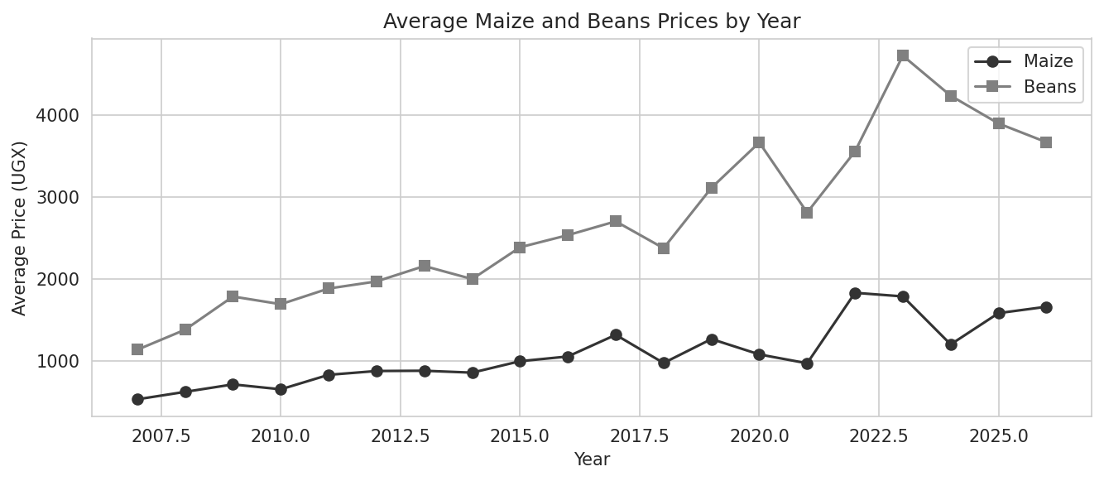
Figure: Figure 4_yearly_trend
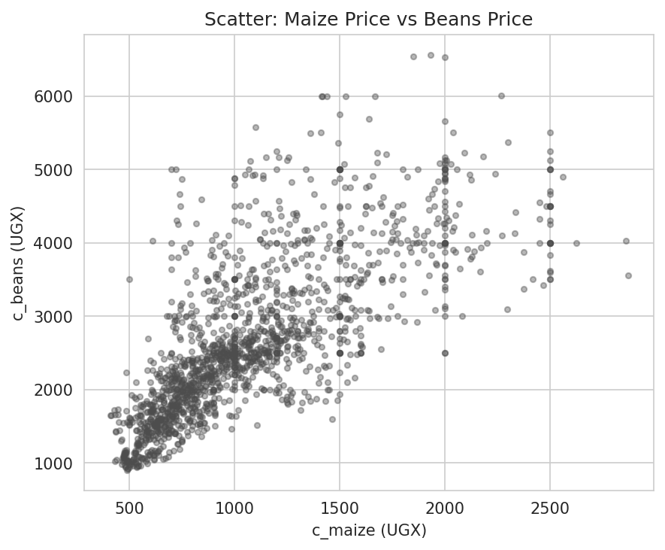
Figure: Figure 5_scatter
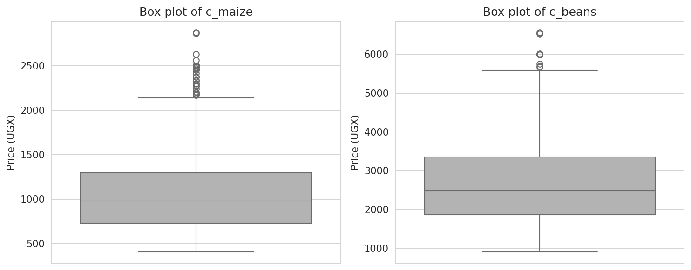
Figure: Figure 2_boxplots

7. Summary of key decisions
Stage | Decision | Reason
Feature selection | Kept the selected variables | They were relevant and interpretable
PCA | Explored but not used | The feature set was already manageable and clear
Class imbalance | Not applicable | This is a regression task
Train/test split | 80/20 split with random_state=42 | Standard and reproducible evaluation
Scaling | Fit on training data only | Prevents data leakage

